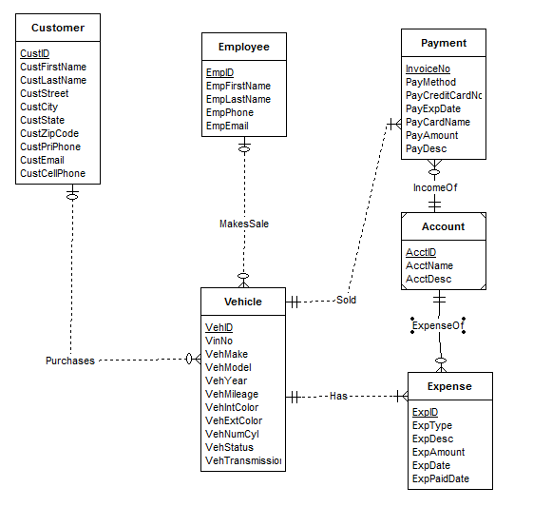

**Errors:**

1. **Vehicle Entity requires additional attribute ‘Transmission type’.**
2. **Customer entity requires both primary phone and cell phone number attributes.**
3. **Purchases relationship should not have a mandatory customer (should be an oval notation) as the narrative indicates vehicles may not be sold for a while.**
4. **MakesSale relationship should also not have a mandatory employee (should be oval notation) because (again!) vehicles tend not to be sold instantly.**
5. **ExpenseOf relationship has several errors. First, the connection to Expense entity should be multiple and optional. Second, the connection to Account should be mandatory and single.**
6. **IncomeOf relationship should correspond to a single, mandatory account since the Account entity is a weak entity.**
7. **The Process relationship is redundant: any employee can be connected indirectly via the Vehicle and Payment entities.**